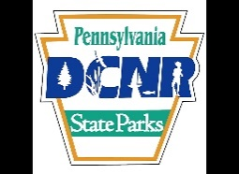
YOUTH, VETERANS, AND MILITARY
WATERFOWL HUNTING DAYS ON PRESQUE ISLE STATE PARK

September 21, 2024: Open to Junior License Holders aged 12-16

October 26, 2024: Open to Junior License Holders aged 12-16 and Veterans and Active Military

January 18, 2025: Open to Veterans and Active Military

Hunters participating in the September 21 hunt must use the orange staked blind locations established for Early Goose Season. A map of these locations is available at the park office. Hunting hours conform to Presque Isle State Park Early Goose Season hours. The October 26 and January 18 hunts follow regular hunting hours set forth by the PA Game Commission.

*Important Information:
- Junior hunters must be accompanied by an adult.
- The adult may assist the youth in calling, duck identification and other aspects of the hunt, but may not be in possession of a firearm.
- Open for ducks, mergansers, Canada geese, gallinules, and coots.
- Same daily duck bag limits as regular season.
- Must follow all established PA Game Commission rules and regulations and PA State Park rules and regulations.

Important Information for the October 26, 2024, and January 18, 2025, hunts:
- All hunters must conform to the 2024 Waterfowl Blind Policies
- Hunting is only permitted from the approved blind locations. Temporary or portable blinds can be used at the approved blind locations during the January 18, 2025, Veterans and Active Military day if the seasonal blind has been removed by the blind holder due to the conclusion of the regular duck hunting season.
- Non-Veteran and Non-Youth hunters may still hunt geese when their season overlaps the special hunt days.

