PRESQUE ISLE STATE PARK

**WATERFOWL BLIND REGULATIONS**

ADDENDUM 2024

Every individual license holder must complete an application for the blind drawing in person. Hunters are not permitted to complete applications for others. Sign-ups will be taken seven days a week at the Tom Ridge Environmental Center (TREC) from 8:00 AM to 4:00 PM beginning on Friday, August 30th through Saturday, September 14th. Also, you may sign up on Sunday, September 15th, outside of the TREC 8:00 AM to 10:00 AM before the drawing. Sign-up dates, times, and locations are listed below:

**IMPORTANT DATES**

|  |  |
| --- | --- |
| **Registration Period** | Opening: Friday, August 30, 2024, at 8:00 AM  Closing: Saturday, September 14, 2024, at 4:00 PM |
| **\*Drawing** | Sunday, September 15, 2024, at 10:00 AM -- TREC, Room 112 |
| **\*\*Issuance of Permits** | Sunday, September 22, 2024, at 10:00 AM -- Picnic Shelter 2 on Presque Isle State Park (see map on next page) |
| **Deadline for**  **Removal of Blinds** | All blinds and blind materials must be removed from the park by sunset, the third Sunday after the close of Lake Erie Zone Duck Season.  For the 2024/2025 season, the deadline for blind removal is Sunday, January 26, 2025, by sunset.  It is recommended that blinds be removed as soon as possible after the season, or when blind holders have finished hunting for the season, rather than waiting for the deadline date. If removing a blind early, notify the park office so the blind location can be allocated to other hunters. |

**\*Drawing:** The drawing will be held at the Tom Ridge Environmental Center. Signups will be accepted from 8:00 AM to 10:00 AM the morning of the drawing outside of the Tom Ridge Environmental Center. At 10:00 AM, Club representatives will enter the Center and set up a FACEBOOK LIVE STREAM with the supervision of park administrators to officiate. The drawing will be done live online and the names of those drawn will be read in order. The listing will then be published immediately afterwards on www.paduck.com.

**\*\*Issuance of Waterfowl Blinds:** **All drawing winners must report by 9:45 AM.** Failure to arrive before the required time will result in blind forfeiture. The pick will take place starting at 10:00 AM on Sunday, September 22nd at Picnic Shelter 2 on Presque Isle State Park. Blind owners will receive a postcard with their drawing order number to pick their blind. Each drawing winner may bring only one guest to help with the selection. The Primary Owner or Co-owner must be present to pick the blind and must have both Primary and Co-Owner’s sets of required signed documents: PA Hunting License, PA Migratory Bird Privileges and Federal Duck Stamp. Failure to have all required signed documents for both Owner and Co-Owner will result in blind forfeiture. No exceptions.

Picnic Shelter 2 Directions: The shelter is located on the corner of the western square pond. To reach the shelter from the park gate, travel approximately 2.6 miles into the park and take the first left turn past the Niagara boat launch. You will be heading back towards the entrance. Then take the first right turn to reach the picnic shelter parking area (see map below).

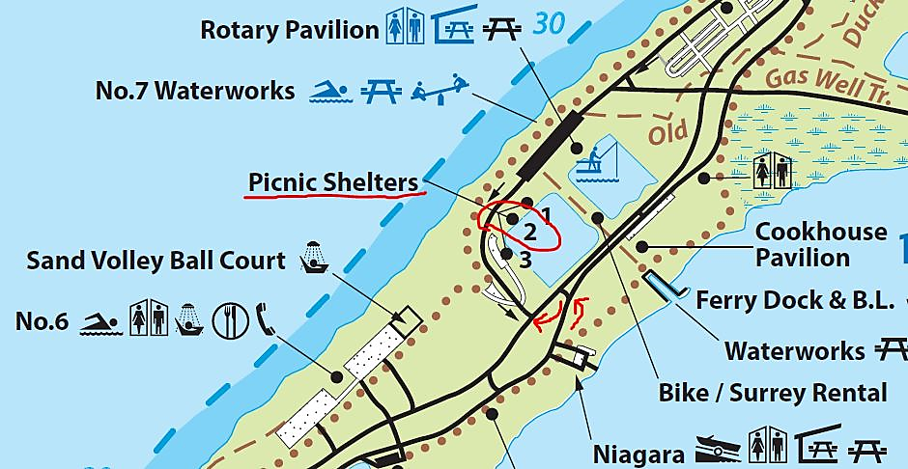

**Water Level May Impact Blind Locations at Beach 11 and Locations on Park -**

The Duck Club and the park will monitor water levels and shoreline configurations prior to and during the waterfowl seasons and may have to relocate or temporarily escrow locations that are unsuitable/unsafe for hunting due to conditions. Individuals selecting Blind #18 on the east shore of Misery Bay by the Coast Guard Station must use a boat to access their blind. Do not trespass on United States Coast Guard property.Due to high water levels, blind locations 1-10, 37-41, 62, 63, 65, 68, 72, and 73 may require boat access. At locations 65, 72, and 73, blind construction is prohibited, instead, buoys will be placed at these locations that allow for the mooring of hunting boats. Blind locations 64 and 66 are temporarily suspended due to high water levels. Due to high water affecting blinds at locations 29, 31, and 32, Duck Club Members will construct and maintain the blinds at these locations. These blinds will not be available to blind drawing winners. They will instead be open for first-come, first-serve, use throughout the season. This will add to the opportunities for those, not selected in the drawing, to hunt.

**Special Note on Littering -**

Littering at or in blinds is a punishable offense. When concluding your hunting session each day, remove all garbage, packaging, shot shells and food from the area. Do your part in protecting Presque Isle and the hunting opportunities that you enjoy. Contact the park office at 814-833-7424, immediately, if you observe violations. Blinds and blind materials left at blind locations after January 26, 2025, will also be considered litter.

**ALL HUNTING DOCUMENTS AND A BLIND OWNERS LIST ARE AVAILABLE AT PADUCK.COM**

**For questions on blind rules and placements, please call Shawn Feiock, 814-882-3473.**